Smith, Mervyn Oliver
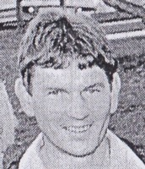
Joined the Forests Department in 1960s as Technical Assistant at Manjimup Working Plans Office. Worked for this branch, Inventory & Planning and Forest Management Branches, before joining the Forests Production Commission when it was formed.

